1. 安装git，从程序目录打开 "Git Bash"
2. 键入命令：ssh-keygen -t rsa -C "email@email.com"
"email@email.com"是github账号
3. 提醒你输入key的名称，输入如id_rsa
4. 在Windows当前登录用户的目录（例如：C:\Documents and Settings\Administrator\）下
产生两个文件：id_rsa和id_rsa.pub
- 把上一步中生成的密钥文件复制到当前登录用户目录的.ssh目录下。
（例如：C:\Documents and Settings\Administrator\.ssh\）
- 登录到服务器，进入自己的Profile文件在SSH Key下点击“Add SSH Key”按钮，将id_rsa.pub
中的内容复制到输入文本域内，然后点击“Add Key”，完成添加SSH Key的公钥。
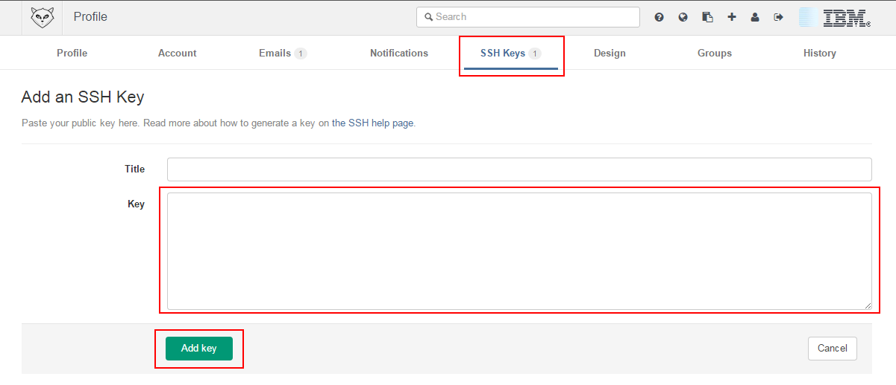

1. Install Git tool, the official website is https://nodejs.org
2. Open "Git Bash" from installation directory, input the command : ssh-keygen -t rsa -C "email@email.com"(email@email.com is account of your Github).
3. Please named the key , e.g : id_rsa
4. Go into the directory of logging in user of windows
(e.g: C:\Documents and Settings\Administrator\), you will find two
files: id_rsa, id_rsa.pub
- Copy two files(id_rsa, id_rsa.pub) into .ssh folder in logging in user's
directory(e.g: C:\Documents and Settings\Administrator\.ssh\)
- Log in the server and enter your profile, under "SSH Key" tab, click "Add SSH Key"
button, copy the content of id_rsa.pub file into text area, and click "Add Key" button
to finish adding public key for SSH.

